
Synopsis
Project Name:
RideMates
Course Code:
CAP463 – CAPSTONE PROJECT
Dated: - 26/02/2026

Submitted by  Name: Samarpreet Singh  Roll No: 43  Reg: 12315307 | Submitted to  Name: Ayushi  UID: 34377

School of Computer Applications
Lovely Professional University
Punjab

Table of Contents
1. INTRODUCTION 3
2. MOTIVATION & PROBLEM STATEMENT 3
2.1 Vulnerability to Strikes & Gridlock 3
2.2 The Hidden Cost of Public Transport 3
2.3 The "Trust Deficit" in Open Networks 3
3. OBJECTIVES OF THE PROJECT 4
3.1 Primary Objectives 4
3.2 Secondary Objectives 4
4. PROJECT SCOPE 4
4.1 Functional Scope 4
4.2 Exclusions (Out of Scope) 4
5. SYSTEM ANALYSIS & METHODOLOGY 5
5.1 Technology Stack (React Native + Node.js + MySQL) 5
6. FEASIBILITY STUDY 5
6.1 Technical Feasibility 5
6.2 Economic Feasibility 5
7. SYSTEM DESIGN (Proposed) 6
7.1 Database Schema 6
7.2 Data Flow 7
8. CONCLUSION 7
9. REFERENCES 7

INTRODUCTION
The modern university ecosystem in Punjab faces a unique logistical challenge: a significant portion of the student and faculty body act as "day-scholars," commuting daily from neighboring cities such as Ludhiana, Jalandhar, and Phagwara. While the distance is manageable (20–40 km), the existing transport infrastructure fails to provide an optimal balance between cost, time, and comfort.
RideMates is a mobile application designed to bridge this gap by creating a university-exclusive peer-to-peer ride-sharing network. The platform focuses on "Asset Utilization" by connecting vehicle owners (students/staff with cars or two-wheelers) who have empty seats with peers traveling along the same route.
Unlike commercial aggregators like Uber or Rapido, RideMates operates on a closed-loop verification system and a non-profit cost-sharing model. By restricting access strictly to users with a valid University Institutional Email (e.g., @lpu.in), RideMates creates a secure, legal, and community-driven alternative to public transport without requiring manual ID card checks.

MOTIVATION & PROBLEM STATEMENT
The development of RideMates is driven by four critical inefficiencies in the current commuting landscape:

Vulnerability to Strikes & Gridlock
The region frequently experiences disruptions due to Bus Worker Strikes, citizen protests (Bandhs), or highway gridlocks caused by accidents. During these events, rigid public transport systems collapse, leaving students stranded. Two-wheelers, however, offer the necessary agility to navigate alternative routes and link roads, ensuring students can reach the university even when highways are blocked.

The Hidden Cost of Public Transport
While public bus tickets appear cheap (₹20–₹30 from Jalandhar, ~₹70 from Ludhiana), the "Total Commute Cost" is significantly higher. Students must pay for auto-rickshaws to reach the bus stand and shuttles to reach their campus block. RideMates offers a "Door-to-Block" service where the fuel-split cost is comparable to the bus ticket, but eliminates the expensive and time-consuming "Last Mile" connections.

The "Trust Deficit" in Open Networks
Existing carpooling solutions (e.g., BlaBlaCar) and bike-taxis (e.g., Rapido) operate on open networks. Students, particularly female commuters, are often uncomfortable sharing a ride—especially a two-wheeler—with unverified strangers on highways.

OBJECTIVES OF THE PROJECT
The primary goal of this project is to develop a robust Android/iOS application that democratizes campus commuting.

Primary Objectives
- To Create an Automated Verified Ecosystem: Implement a strict approach where every user is authenticated via Domain-Restricted Email Verification. Only users who can access a valid @university.in inbox can register.
- To Optimize Two-Wheeler Commuting: Leverage the high density of bikes/scooters to provide an agile commuting option that is resilient to traffic jams and strikes.
- To Implement a Non-Commercial Cost Model: Develop a "Fair-Share Algorithm" that calculates fuel costs based on Standardized Vehicle Categories (e.g., Scooter, Bike, Car), enforcing a Price Cap to prevent commercial profit.

Secondary Objectives
- Strike Resilience: To enable a "Route Agility" feature where drivers can tag rides as "Emergency/Alternative Route" during public transport strikes.
- Social Networking: To transform dead commute time into networking opportunities between juniors and seniors.
- Trust Gamification: To implement a "Trust Score" system that penalizes users for last-minute cancellations.

PROJECT SCOPE

Functional Scope
- User Module: Automated Registration via University Email OTP (One Time Password), Profile Management.
- Ride Management: Post Ride (One-Time), Search Ride, Filter by Visual Vehicle Categories (e.g., "Two-Wheeler", "Fou-Wheeler").
- Safety Module: "Gender-Lock" (Female-to-Female only filter), "Spare Helmet" Checkbox.
- Booking Module: Auto-booking engine with SQL transaction locking to prevent double-booking.
- Notification Module: "Ride-Alert" subscription for route availability.

Exclusions (Out of Scope)
- Real-Money Payment Gateway: To avoid banking regulations and complexities, the app will facilitate offline settlements (Cash/UPI) based on the calculated split amount.
- Live GPS Navigation: The app matches users based on "Source/Destination" text logic.
Live turn-by-turn navigation is excluded to reduce battery drain and complexity.
- Manual ID Verification: The system relies entirely on the security of the University's Email Server for identity proof.

SYSTEM ANALYSIS & METHODOLOGY

Technology Stack (React Native + Node.js + MySQL)
- Frontend: React Native – Chosen for its ability to compile to native Android/iOS code using JavaScript.
- Backend: Node.js & Express.js – Chosen for non-blocking I/O, essential for handling concurrent booking requests.
- Database: MySQL – A Relational Database Management System (RDBMS) is critical for maintaining structured relationships between Users, Rides, and Trust Scores.
- Authentication: Firebase Auth – Configured to allow sign-ups only from the university domain (e.g., *@lpu.in).

FEASIBILITY STUDY

Technical Feasibility
The project utilizes open-source technologies. The team possesses the requisite skills in React Native and SQL. The "Email Verification" feature is natively supported by Firebase, reducing development risk and ensuring 99.9% uptime.

Economic Feasibility
The project requires zero capital investment. Hosting will be managed via free-tier cloud services. The app relies on the existing hardware (smartphones) of the users.

SYSTEM DESIGN (Proposed)

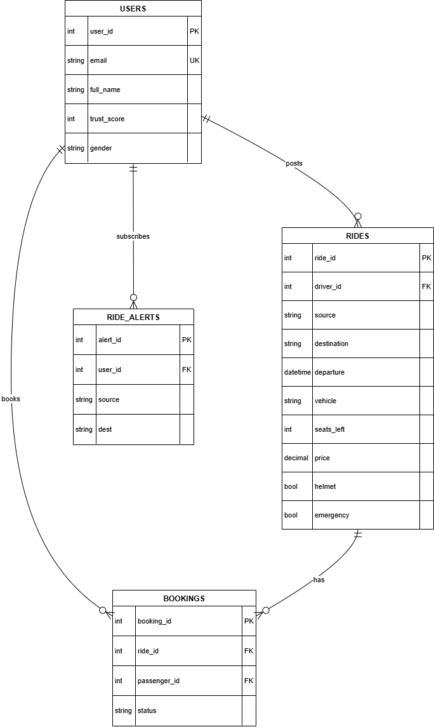
Database Schema

Data Flow
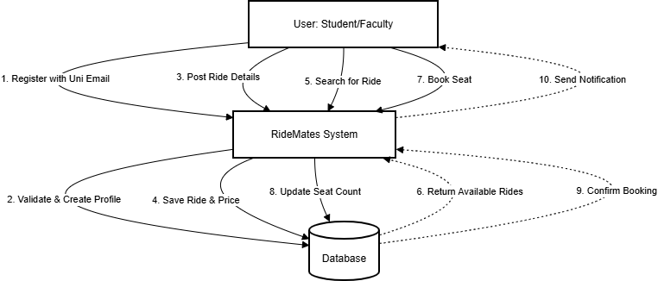

CONCLUSION
RideMates represents a shift from "Transactional Transport" to "Community Commuting." By solving the specific pain points of the university demographic—namely cost, safety, and resilience against civil disruptions—it provides a vital utility. The project is technically challenging, socially responsible, and economically viable, making it a strong candidate for a Capstone Project.

REFERENCES
- Motor Vehicles Act, 1988 (Section 66) – Regarding private vehicle usage.
- Case Study: BlaBlaCar – Analyzing the trust model of long-distance carpooling.
- React Native Documentation – For cross-platform mobile development standards.

